**PART A**

**EXPERIMENT NO. 6**

**A.1 AIM: -** To draw the State Diagram

**A.2 Prerequisite**

Determine the State Diagram for the case study.

**A.3 Outcome**

After successful completion of this experiment students will be able to -

1. Practice drawing the state diagrams using StarUML

**A.4 Procedure/Algorithm**

**A.4.1 Task:**

Draw a state diagram for the case study.

**PART B**

(PART B: TO BE COMPLETED BY STUDENTS)

*(Students must submit the soft copy as per the following segments within two hours of the practicals. The soft copy must be uploaded on Blackboard LMS or emailed to the concerned Lab in charge Faculties at the end of practical; in case Blackboard is not accessible)*

|  |  |
| --- | --- |
| Roll No: C101 | Name: Samkeet Shah |
| Class: C | Batch: B3 |
| Date of Experiment: | Date of Submission: |
| Grade: |  |

**B.1 User Interfaces**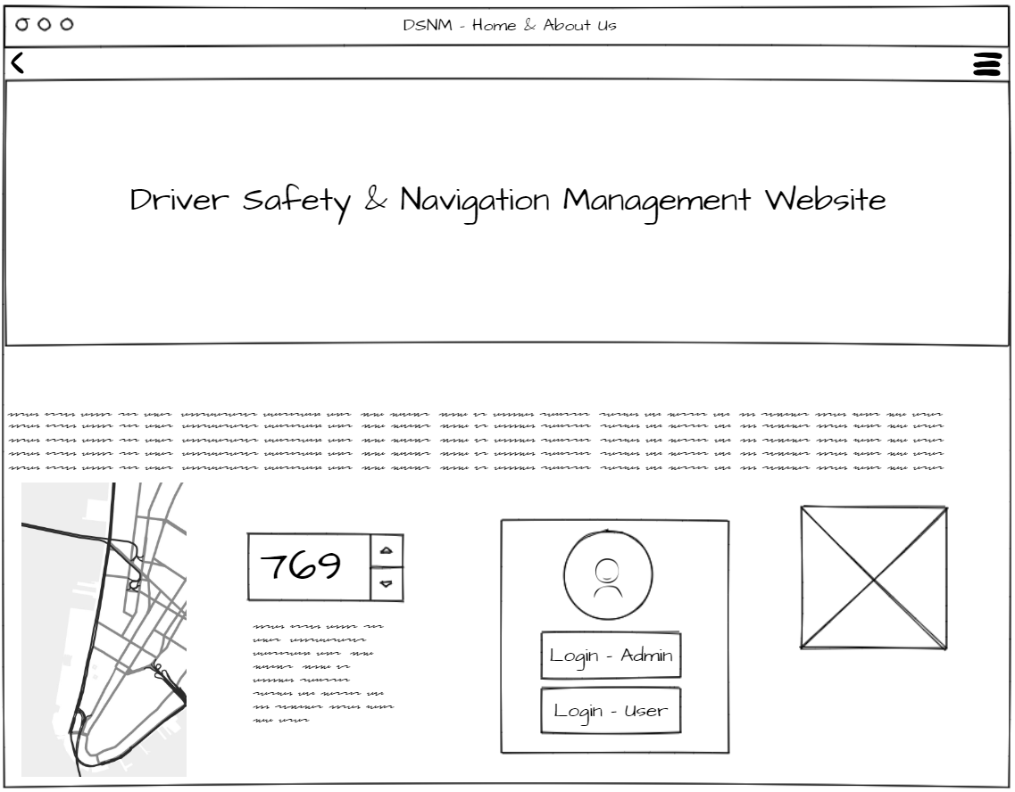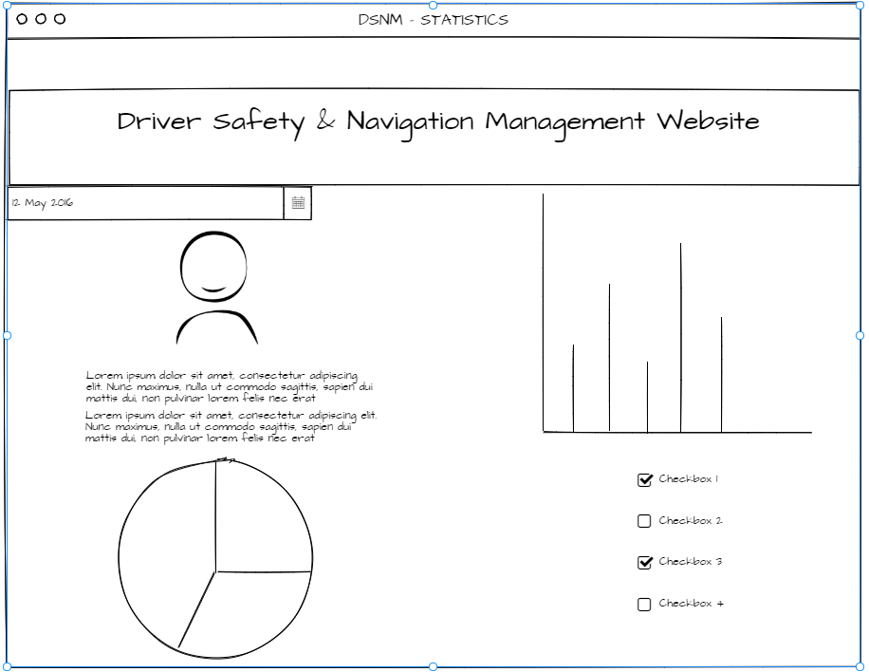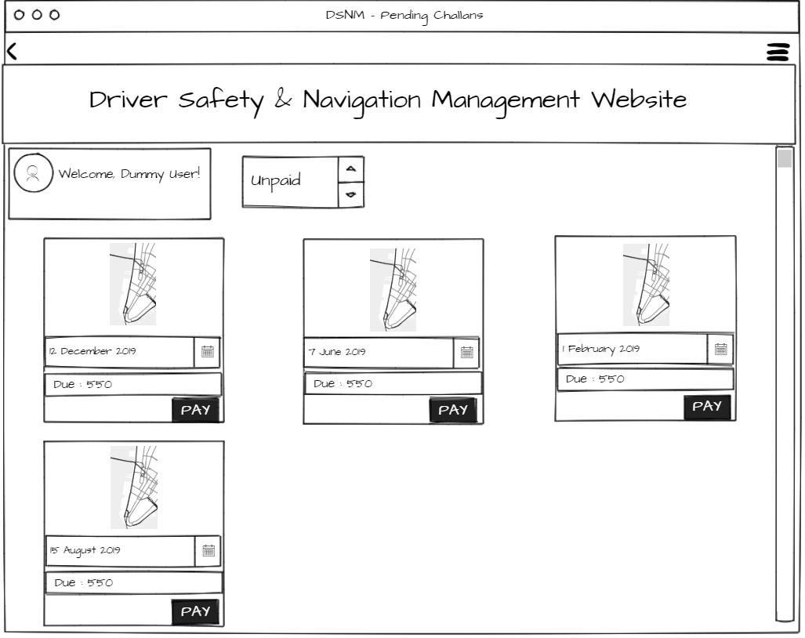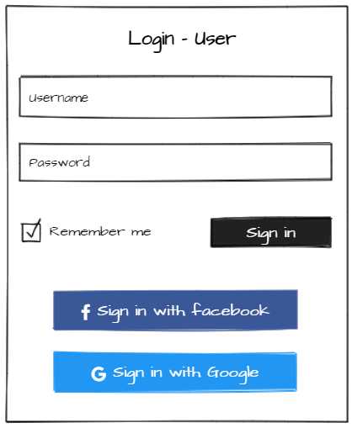

**B.2 State Diagram**

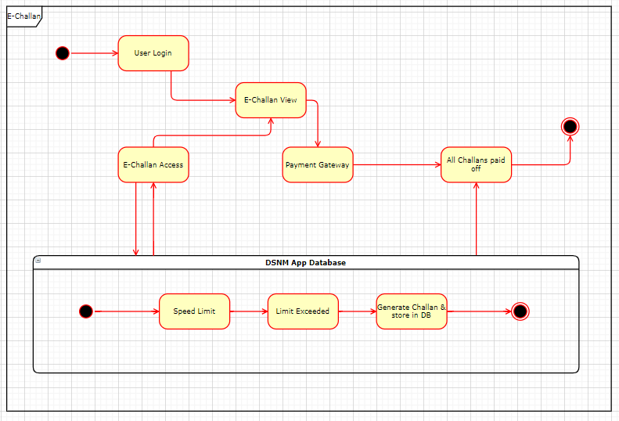

**B.3 Conclusion**

Understood the concepts related to the state machine and implemented a wireframe for the UI of the system.